Title: Machine Learning-Based Earthquake Magnitude Prediction

Abstract:
Earthquakes are among the most destructive natural disasters, causing significant damage to human life, infrastructure, and the environment. Predicting earthquake magnitude using traditional statistical methods is challenging because seismic events are highly complex and nonlinear. This project proposes a Machine Learning-Based Earthquake Magnitude Prediction System that analyzes historical seismic data to estimate the magnitude of future earthquakes. The system uses earthquake parameters such as latitude, longitude, depth, time, and seismic measurements as input features. After preprocessing the dataset through data cleaning, normalization, and feature selection, machine learning algorithms such as Linear Regression, Random Forest Regressor, Decision Tree Regressor, XGBoost, and Artificial Neural Networks (ANN) are trained and evaluated. Model performance is measured using metrics including Mean Absolute Error (MAE), Mean Squared Error (MSE), Root Mean Squared Error (RMSE), and R² Score. The proposed system assists researchers and disaster management authorities by providing more accurate earthquake magnitude predictions, supporting early preparedness and risk mitigation strategies.

Datasets:

Dataset | What it contains | Link
USGS Earthquake Catalog ⭐ | Magnitude, latitude, longitude, depth, time, location | USGS Earthquake Catalog
Kaggle Earthquake Database ⭐ | Historical global earthquakes with magnitude, coordinates, depth, date/time | Kaggle Earthquake Database
IRIS Seismic Data | Earthquake and seismic waveform data | IRIS Data Services
NOAA Earthquake Database | Historical earthquake events, magnitude and geographic information | NOAA Earthquake Search
Global Earthquake Model (GEM) | Global earthquake hazard and seismicity data | GEM Foundation

Approach:
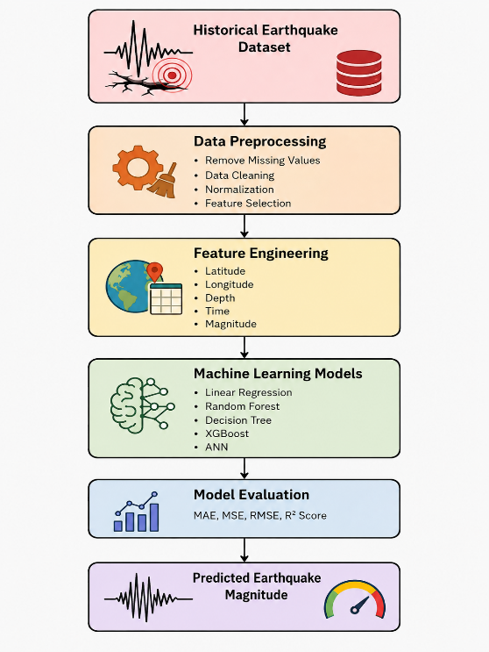

Flow chart:
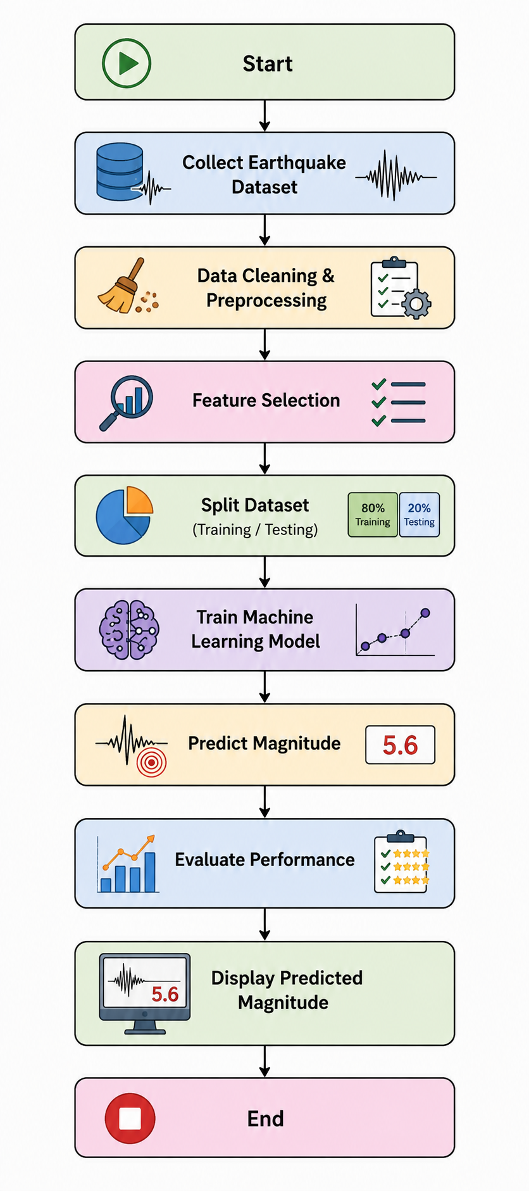

Project Group Members:

Roll no | Name
2420090043 | Rahul
2420030280 | Saisujith
2420030280 | Nikhileash
2420030782 | Sumanth Reddy

